**Lab objectives:**

**Create an RPGLE program that implements concepts from previous labs. Screen Design and validation from Lab3, Payroll calculations from Labs 5 and 6 and updates and deletes from Lab 7.**

**Students will have until the end of the semester to solve this lab and this lab will be the first one with minimal instructor help**

**Requirements to pass the lab:**

**Run a CLLE program that puts original data from SENECAPAY/EMPLOYEE and SENECAPAY/WORKWEEK1 into your Employee and Workweek1 files which reside in your collection called LAB8??? (where ??? is the last part of your id). and successfully run an RPGLE program that can report on the Employee and his pay for a workweek and potentially update the Employee and Workweek1 files. Your CLLE program will show the files before they are updated and when the RPGLE program is exited show the files after they were updated. Then it will show the journal entries for each file.**

This application will be demonstrated by your instructor in a class recording which you can replay to make sure your program covers all the necessary steps.

INPUT: WORKWEEK1

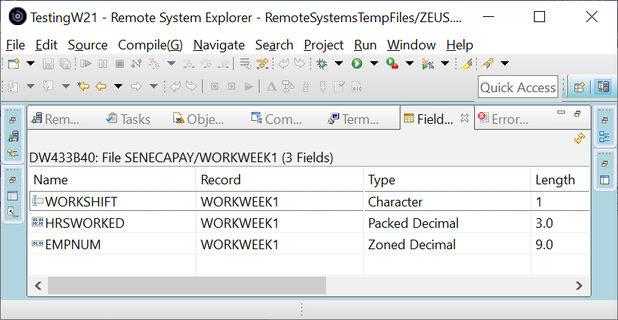

Note some differences between WORKWEEK1 and SHIFTWEEK from Lab 5.

There is no zoned decimal PayClass field. It has been moved to the EMPLOYEE file and is a character field with a name of PayGrade. The numbers retain their same meaning used for lab 5.

WORKSHIFT uses a different code for the shift. A – Afternoon, D – Day and N – Night. As in Lab5, you pick up the rates for the workshift from the SHIFTRATES file in SENECAPAY.

Do not copy the SHIFTRATES file to your library. Your instructor may change the rates and you want to pick up the latest rates.

EMPLOYEE

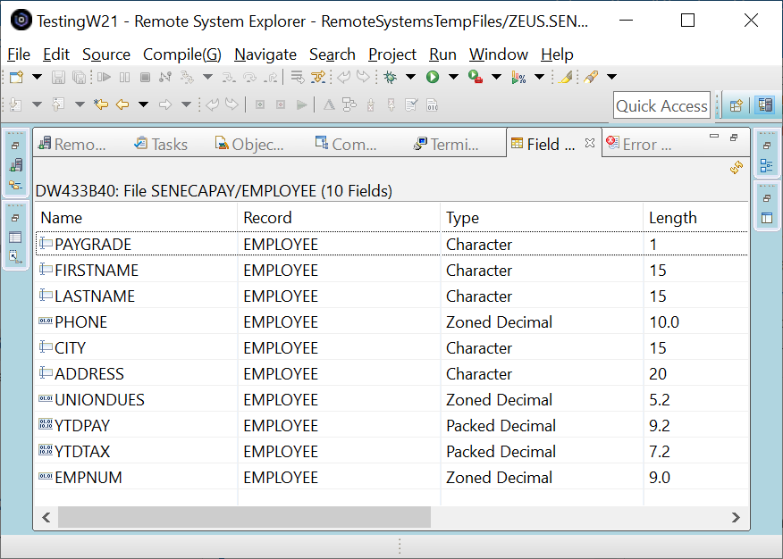

The pay grade, city and address fields are updatable. When an update is requested YTDPAY is also updated with the shift pay earned by the worker calculated based on information from both the EMPLOYEE and WORKWEEK1 files. An update is performed if the manager was viewing the employee information from both files and presses the F6 key. When that happens, the record for that employee is removed from the WORKWEEK1 file, so the worker does not get paid twice when batch processing is done for WORKWEEK1.

The manager can simply view the employee information without pressing F6. If that occurs they can either press Enter to look up another employee or F3 to exit from the program.

If a matching employee record is not found in the Employee file or in the WORKWEEK1 file, the user will be informed and have to enter a different employee number. For testing there are employees that match 111111111, 222222222 through 555555555 in the original data.

The following screenshots show a sample run of the program.

DATA in WORKWEEK1 (employee 111111111 is included in the file)

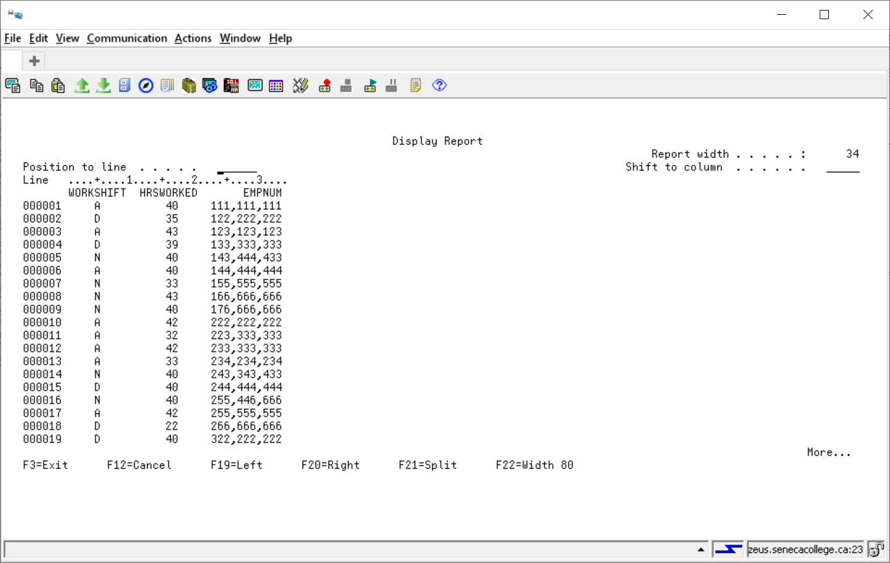

Data in EMPLOYEE (note the ADDRESS, CITY AND YTDPAY for employee 111111111)

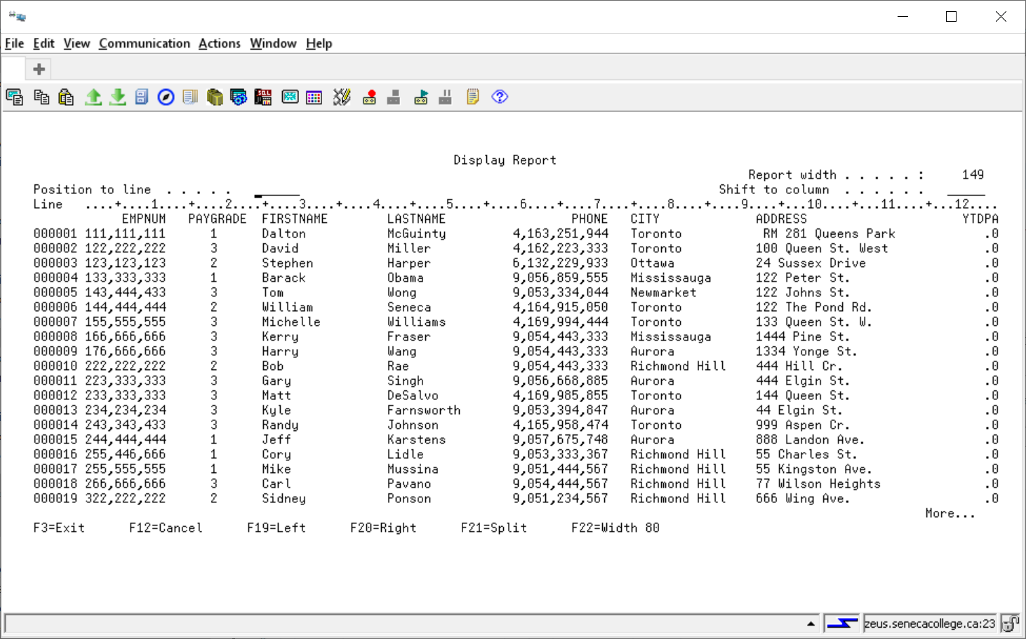

The RPGLE program is running and the manager wants to view employee 111111111

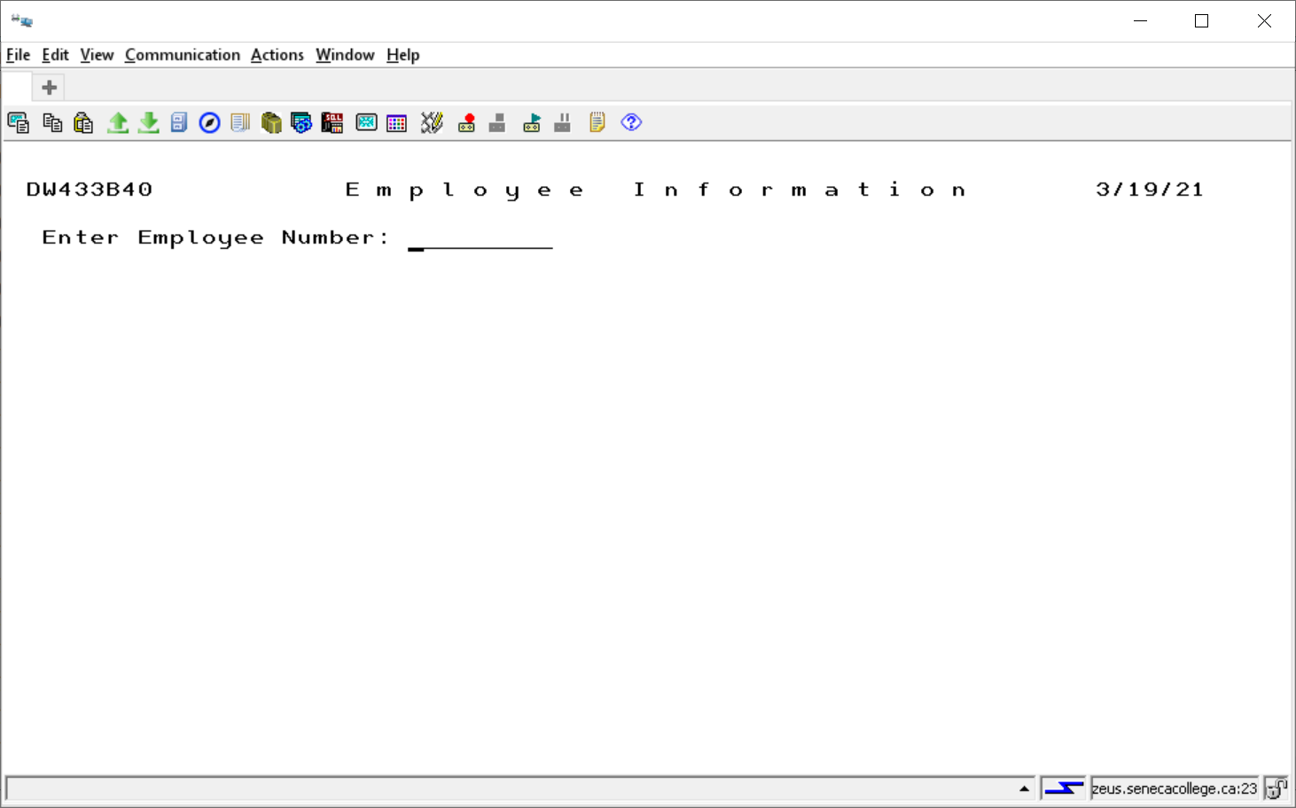

If the manager presses ENTER, nothing is updated. The Pay Grade, City and Address fields are changeable.

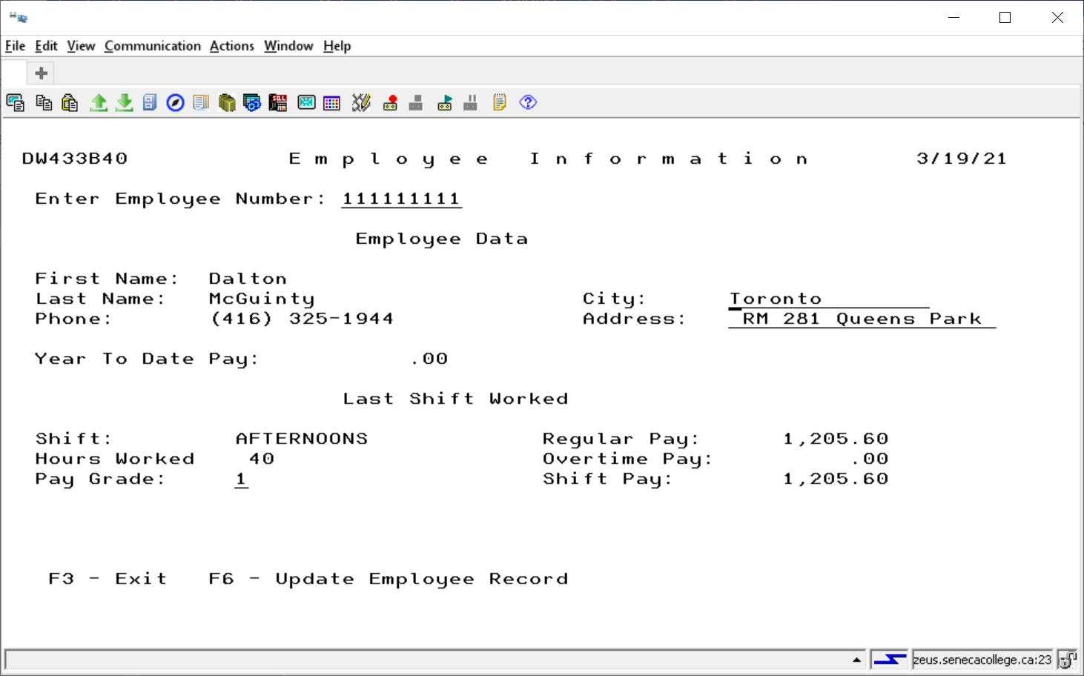

The Pay Grade, City and Address fields have been changed. If the manager presses ENTER or F3, nothing is updated. If the manager presses F6 the EMPLOYEE record will have three fields updated. Note that just updating the city or address doesn’t not mean recalculating the Shift Pay, but if the Pay Grade has been changed the manager has decided to upgrade or downgrade the workers pay and the new shift pay is applied to the year to date pay, **not the shift pay that is showing on the screen.**

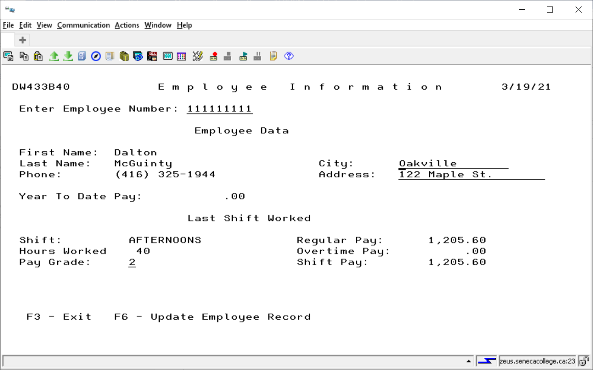

F6 was pressed and the 111111111 record was removed from the WORKWEEK1 file and the EMPLOYEE record was updated. The manager viewed another existing record to get access to the F3 key and exited from the RPGLE program. The CLLE program is showing the changed files. There is proof that the 111111111 record was removed.

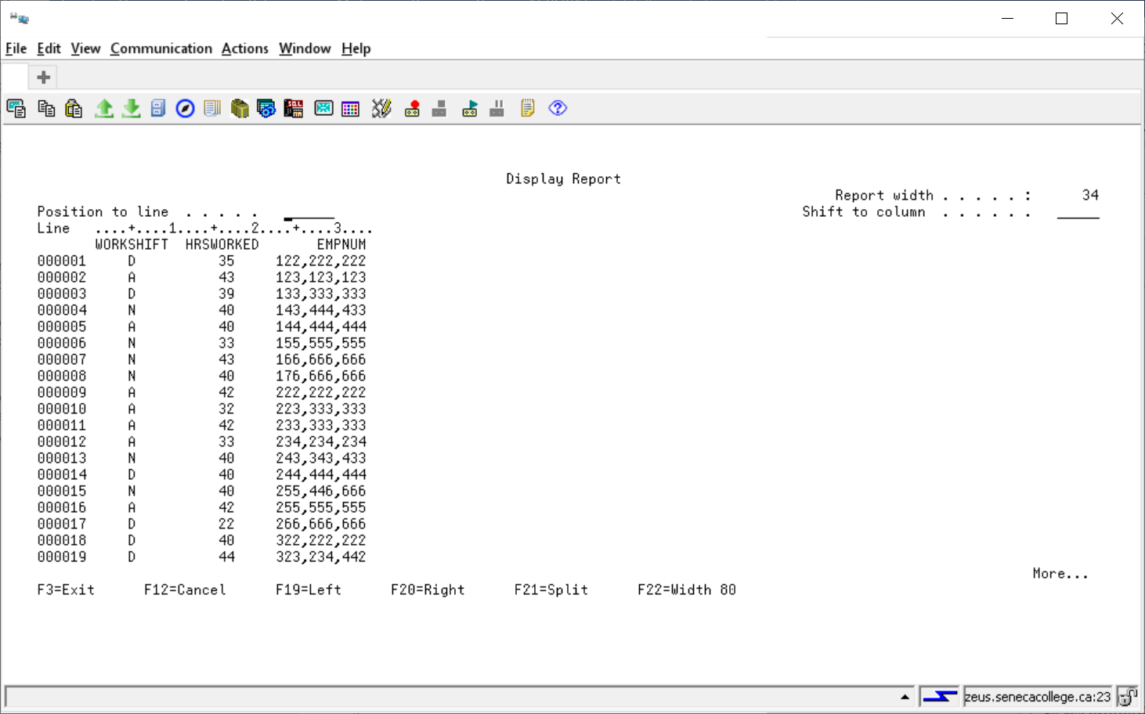

Three fields have been updated, the YTDPAY field was added to, and the pay grade, city and address fields were changed

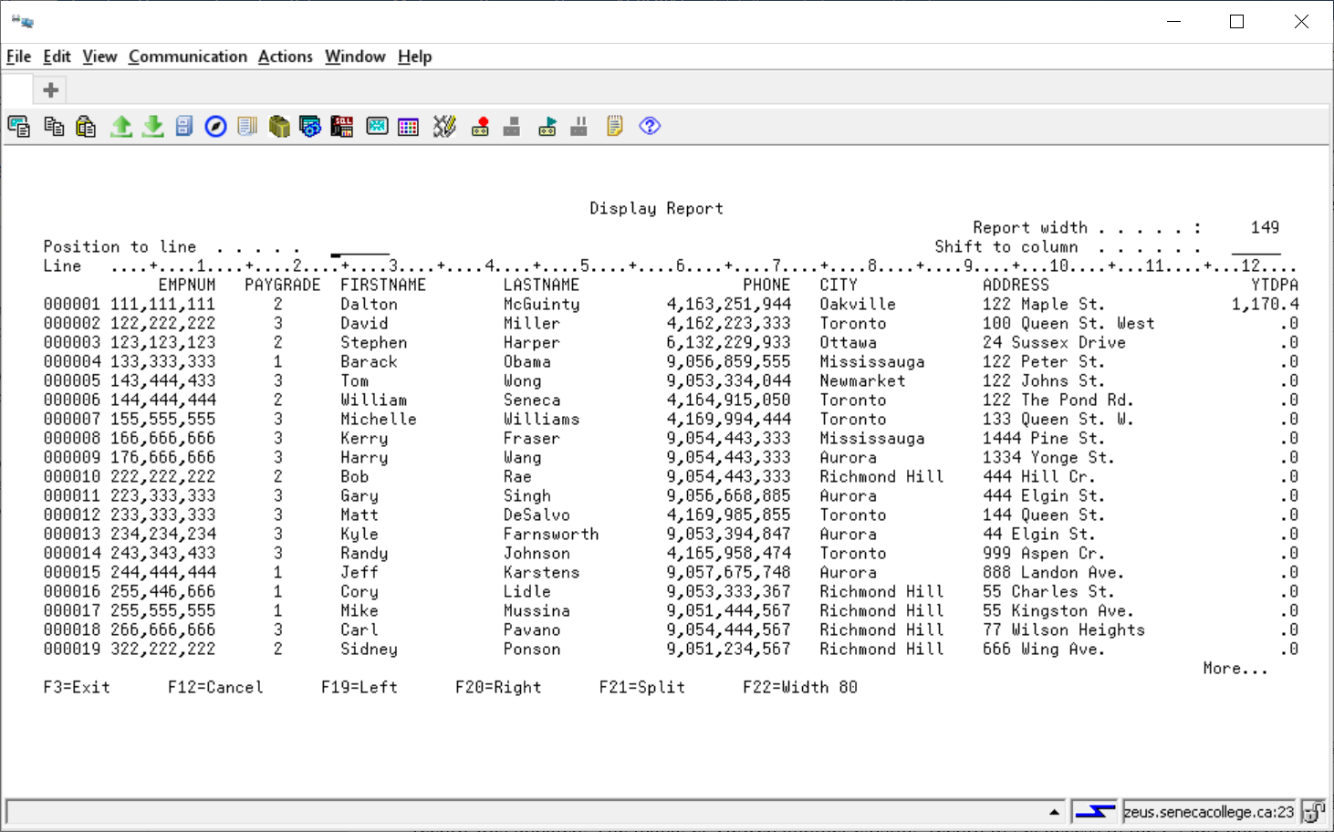

If the manager had tried to view the 111111111 record again this message would appear, because the record was removed from the WORKWEEK1 file.

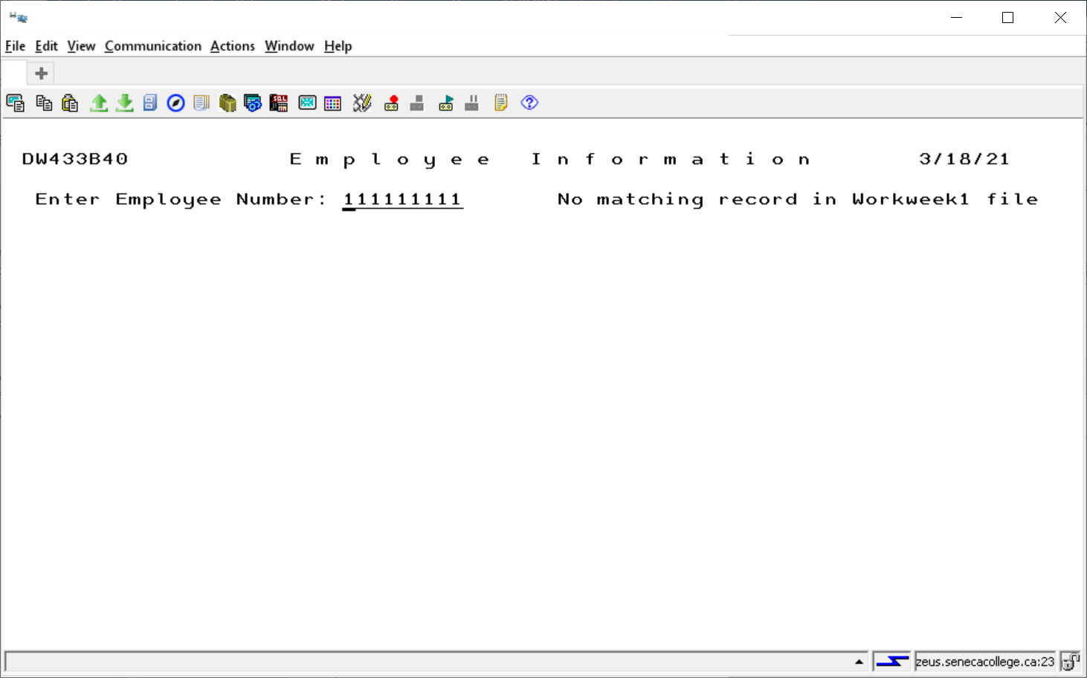

This is another possible error message when running the RPGLE program.

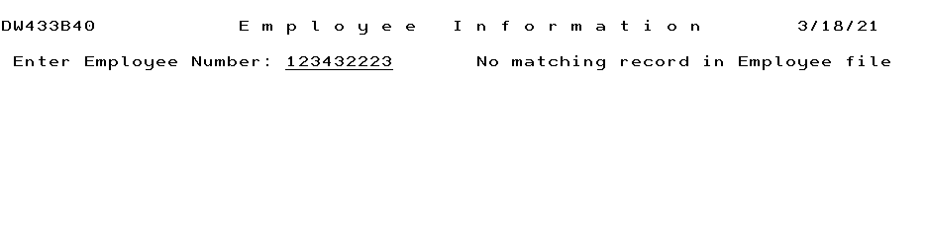

This is looking at EMPLOYEE specific updates

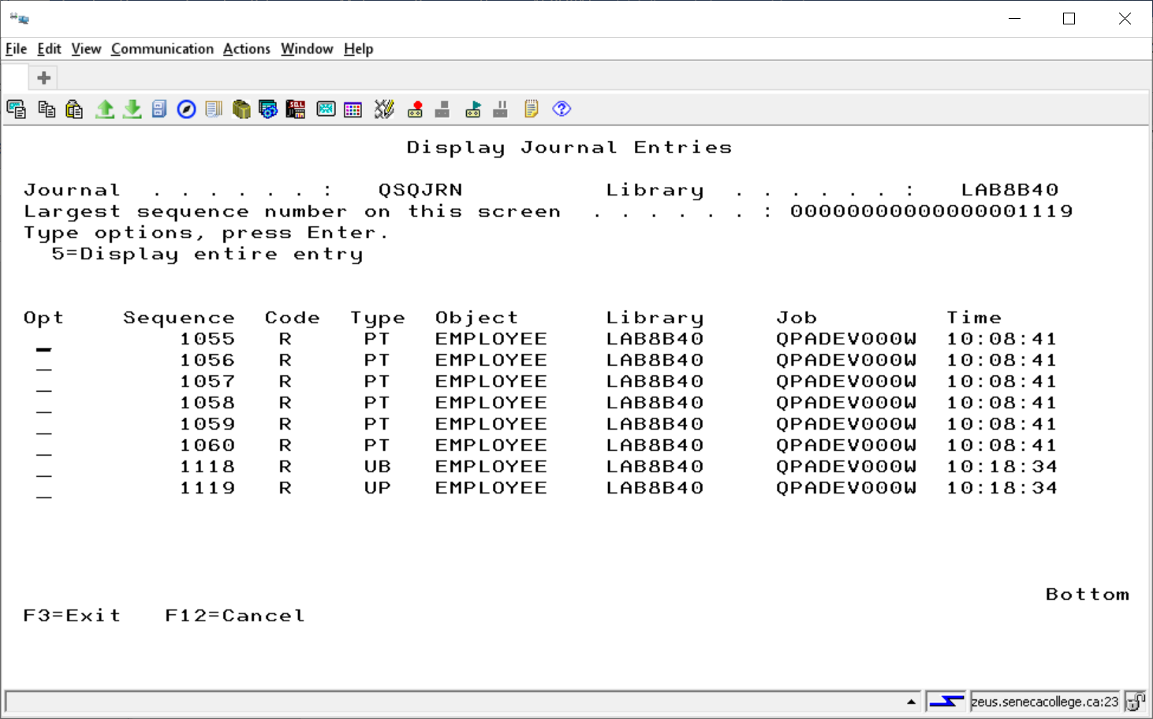

This is looking at WORKWEEK1 updates

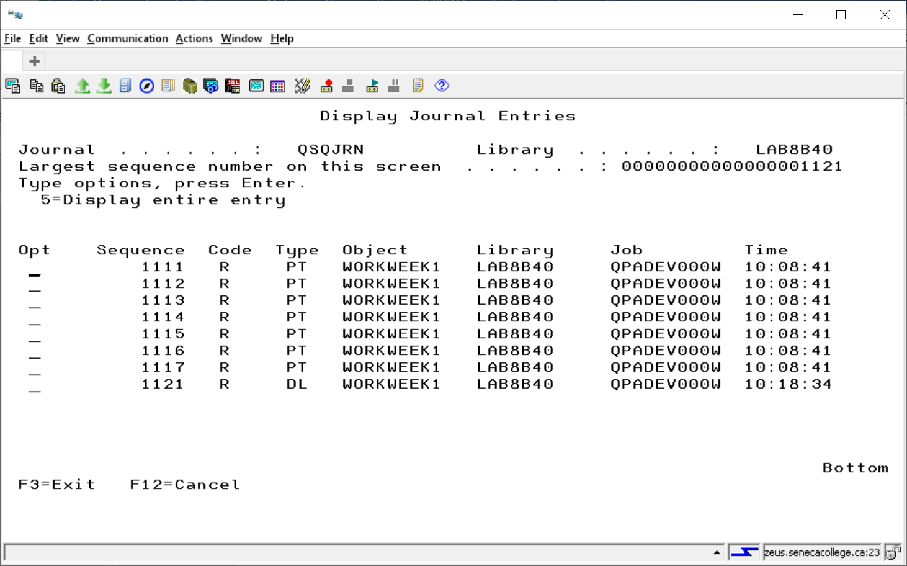

Some hints for your display files.

Grab and drop fields from the file in your collection. To allow lower case data entry use CHECK(LC). The City field does not need a transaction name and a master name. A single name works for the update.



You can reference the paygrade field, but you need a different name since this involves recalculating the pay if the manager decided to either add or take away from the pay for the employee. We can now this if it the value is different than the original. You do not need to recalculate the pay if the pay grade was not changed. Also, validate the pay grade.

